Vocabulary from “The Most Dangerous Game”

Name______________________________ Period _________ Date_______________

Word | Part of speech | Context | Visual representation | Definition in your own words
Palpable | Adj. | “Can’t see it,” remarked Rainsford, trying to peer through the dank tropical night that was palpable as it pressed its thick warm blackness in upon the yacht. | 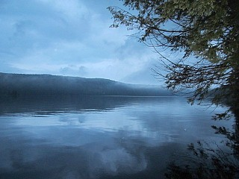 | Capable of being touched, but used to describe things that can’t actually be touched
Indolently |  | Rainsford, reclining in a steamer chair, indolently puffed on his favorite brier
Flounder |  | It was easier to go along the shore, and Rainsford floundered along by  the water.
Quarry |  | I suppose the first three shots I heard was when the hunter flushed his quarry and wounded it.
Cultivated |  | In a cultivated voice marked by a slight accent that gave it added precision and deliberateness…
Aristocrat |  | He had high cheekbones, a sharp, cut nose, a spare, dark face—the face of  a man used to giving orders, the face of an aristocrat.
Amenities |  | “We do our best to preserve the amenities of civilization here.”
Debacle |  | “After the debacle in Russia I left the country, for it was imprudent for an officer of the Czar to stay there.”
Imprudent |  | “After the debacle in Russia I left the country, for it was imprudent for an officer of the Czar to stay there.”
Condone |  | “Surely your experiences in the war… did not make me condone coldblooded  murder," finished Rainsford  stiffly.
Droll |  | “How extraordinarily droll you are!”
Scruples |  | “But I think I can show you that your scruples are quite ill founded.”
Zealous |  | Even so zealous a hunter as General Zaroff could not trace him there…
repast |  | “Splendid! One of us is to furnish a repast for the hounds.”

